Laptop Price prediction report
1.Introduction:
The goal of that project is to build a machine learning model that predicts the laptop prices using the provided training dataset and then generates predictions for the unseen test dataset. The target variable is Price (Euro).
2.Data understanding and EDA
We used in data understanding:
- Dataset shape -> which show the dataset have how many columns and rows (help us to understand the data)
- Data types -> which show the type of the columns that we have (with it we differentiate between the numerical data and the categorical data which will help us in the encoding and multiple things)
- Missing values -> to check how many rows have missing values in columns (help us in the filling or handle it so it does not make the data worse)
- Duplicates -> it show us if there is any duplicates rows and if it found we should delete the data because it is an duplicate
- Number of unique values in each column -> it show how many unique values in the each column

Price by Company
Razer, LG, and Microsoft Surface consistently command the highest average prices. Lenovo and HP offer the widest price range, covering both budget and professional segments. Chuwi and Mediacom sit at the budget end.

Price by CPU Company
Intel-powered laptops average significantly higher prices than AMD-powered ones, partly reflecting the era of the dataset (pre-Ryzen premium era).

Price by Type
Gaming and Workstation laptop types show the highest average prices. Chromebooks and Netbooks are consistently the cheapest.

Correlations with Price
The strongest positive correlations with price among raw numeric features are RAM (GB) (r ≈ 0.60), CPU_Frequency (r ≈ 0.47), and Weight (r ≈ 0.35). Screen size (Inches) correlates weakly at r ≈ 0.15.

Visualization:

Visualization: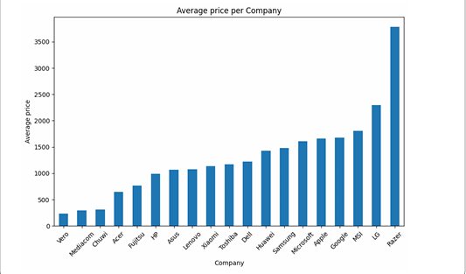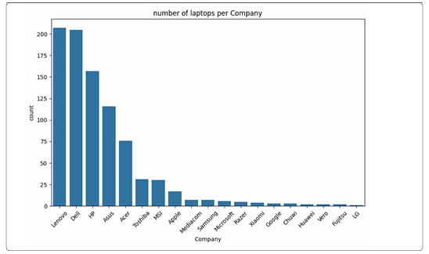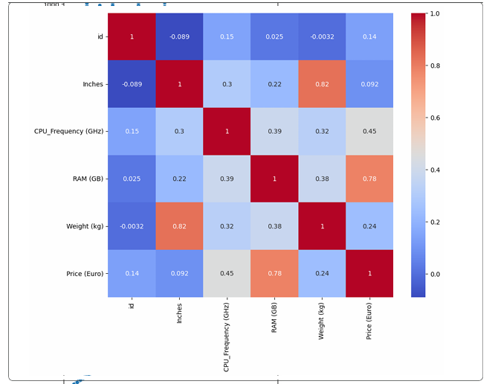

3.Data preparation and preprocessing:
1.we removed the unnecessary column like the id because it is a column that does not describe a laptop specification and it is not related to the target that we want to do prediction to it which is Price (Euro)
2.we have handled the text based features like for the cpu we have separated it to cpu_family and cpu_generation and cpu_suffix and then we dropped the cpu type
also for the memory we have separated it to the numbers and the storage number and we also have do a flags ssd or hdd or hybrid and do a column that have the total storage and then we dropped the memory
also for the gpu we separated it and extract it to gpu families and then we dropped the gpu type
also the resolution we have handled it by doing new feature which ppi that combine between width and height which we extract from the resolution and also the inches then we dropped the inches and width and height and resolution
also the product we extract from it the important info and dropped it is column
3.we handled the missing values in the generation and the suffix by fill it with none and unknown
Encoding:
We have used the one hot encoding to convert the categorical values into numerical which needed to train on the data

4.Modeling:

Linear Regression
Linear Regression was used as a baseline model to predict laptop prices from the engineered dataset. Before training the model, the target variable was defined as Price (Euro), the id column was removed, and the remaining predictors were prepared through preprocessing and feature engineering. The dataset size after separating features and target was 881 training records, and after feature engineering the final training matrix contained 26 input features. These included both original and engineered attributes such as CPU frequency, RAM, weight, screen quality indicators, storage characteristics, CPU-derived categories, product series, and GPU series.
Several feature engineering steps were applied to improve the quality of the inputs for the linear model. From the ScreenResolution column, two binary variables were created to indicate whether the laptop has an IPS panel or touchscreen support, and the resolution was converted into pixels per inch (ppi). From the Memory column, storage was separated into SSD, HDD, flash, and hybrid capacities, and additional indicator variables such as has_ssd and has_hdd were created. The CPU_Type column was split into more meaningful attributes such as CPU family, core class, suffix, and generation. In addition, the product name and GPU type were simplified into grouped categorical features such as product_series and gpu_series. After these steps, there were no missing values and no column mismatch between training and test data.
Because Linear Regression is sensitive to feature scale and cannot work directly with text categories, a preprocessing pipeline was used. Numerical variables were standardized using StandardScaler, while categorical variables were converted using OneHotEncoder with handle_unknown="ignore". This preprocessing was combined with the regression model inside a Pipeline, which ensured that the same transformations were applied consistently during both training and validation. The data was then divided into training and validation sets using an 80/20 split, resulting in 704 samples for training and 177 samples for validation. A 5-fold cross-validation strategy with shuffling and a fixed random state was used to evaluate the model more reliably.
The Linear Regression model achieved cross-validation R² scores of 0.7783, 0.8263, 0.8867, 0.8752, and 0.8375, with a mean CV R² of 0.8408 and a standard deviation of 0.0385. On the holdout validation set, the model produced a Validation R² of 0.8833, RMSE of 267.36, and MAE of 177.63. These results show that the model explained a large proportion of the variance in laptop prices and provided a strong baseline performance.
To further evaluate the model, an Actual vs Predicted scatter plot and a Residual Plot were generated. The actual vs predicted graph showed that many predictions were close to the ideal diagonal line, which indicates that the model captured the general relationship between features and price. The residual plot was used to inspect prediction errors and check whether the errors were randomly distributed around zero. A learning curve was also plotted using training and validation mean squared error. This helped assess how model performance changed with more training data and provided insight into whether the model was suffering from high bias or high variance.
Overall, Linear Regression served as an effective baseline model in this project. It worked well because the preprocessing pipeline transformed the mixed numerical and categorical dataset into a suitable machine learning format, while feature engineering extracted more informative predictors from complex text columns. Although later models such as Ridge performed slightly better, Linear Regression still gave strong and interpretable results, making it an important benchmark for comparing all other regression approaches used in the project.
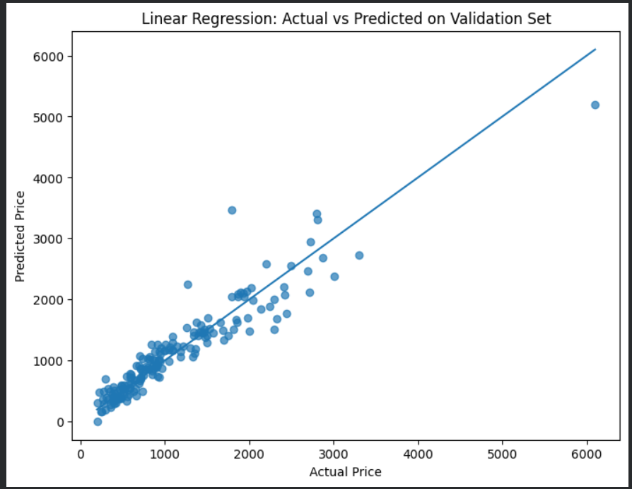
Ridge Regression
Ridge Regression was used as an improved version of Linear Regression in order to reduce overfitting and handle the large number of encoded and engineered features more effectively. Since the dataset contained many categorical variables transformed by one-hot encoding, Ridge was suitable because it adds an L2 regularization penalty to the loss function, which shrinks coefficient values and makes the model more stable. The same prepared dataset used for Linear Regression was also used here, including the engineered features from screen resolution, memory, CPU type, product series, and GPU series.
The preprocessing pipeline for Ridge Regression was exactly the same as the one used for Linear Regression. Numerical features were scaled using StandardScaler, and categorical features were transformed using OneHotEncoder with handle_unknown="ignore". These preprocessing steps were combined with the Ridge model inside a Pipeline, which ensured that all transformations were applied consistently during training, validation, and cross-validation. The data was split into training and validation sets using an 80/20 holdout split, and a 5-fold KFold cross-validation with shuffling and a fixed random state was used to evaluate the model.
First, a baseline Ridge Regression model was trained using alpha = 1.0. This baseline model was evaluated using cross-validation and then tested on the validation set. The purpose of this step was to check whether adding regularization could improve performance compared with ordinary Linear Regression. After that, hyperparameter tuning was performed using GridSearchCV to find the best value of the regularization parameter alpha. The tested values were 0.001, 0.01, 0.1, 1, 5, 10, 20, 50, and 100. This helped identify the amount of regularization that gave the best balance between model flexibility and generalization.
The tuned Ridge model selected the best alpha based on cross-validation performance. After selecting the best estimator, the model was retrained on the training data and evaluated on the validation set using R², RMSE, and MAE. This tuned version performed better than the baseline Ridge model and slightly better than standard Linear Regression, which showed that regularization improved the model’s ability to generalize to unseen data.
In addition to the standard Ridge model, another experiment was done using a log-transformed target variable. In this approach, the target price was transformed using log1p(y) before training, then predictions were converted back to the original scale using expm1(). This was done because laptop prices are often right-skewed, and applying a logarithmic transformation can reduce skewness and make the relationship between predictors and target more linear. After converting the predictions back to the original scale, the model was again evaluated using R², RMSE, and MAE on the validation set.
Overall, Ridge Regression was one of the strongest models in this project. It kept the advantages of Linear Regression while reducing the effect of overfitting through regularization. It was especially useful because the dataset contained many engineered and one-hot encoded features, which can make ordinary linear models unstable. For this reason, Ridge Regression was selected as the final model for generating test predictions and submission files.
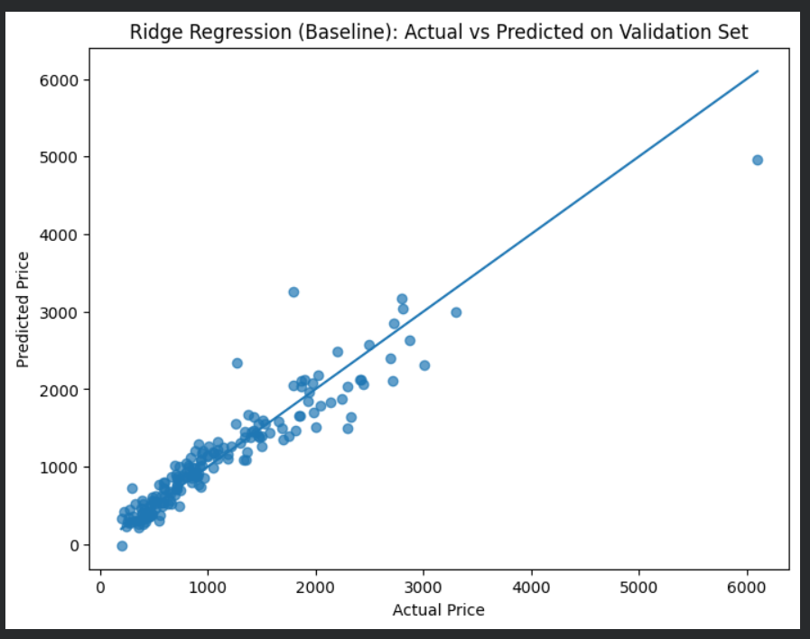
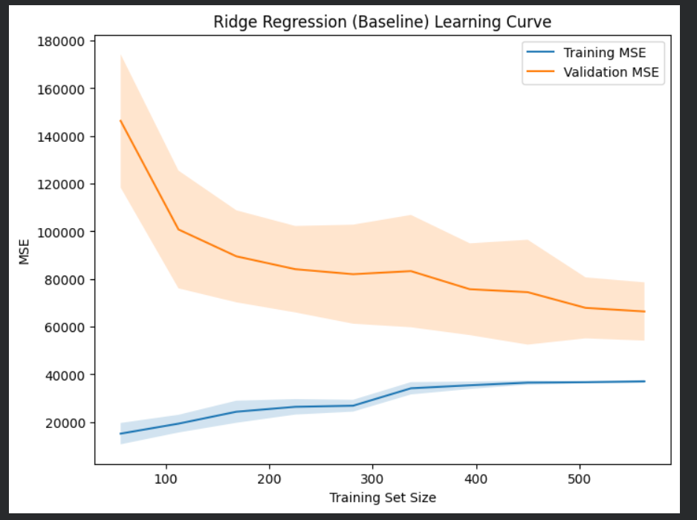

Lasso Regression
Lasso Regression was used as another regularized linear model to predict laptop prices. Like Ridge Regression, it is based on linear regression, but instead of using L2 regularization, Lasso applies L1 regularization. This penalty shrinks some coefficient values and can force others to become exactly zero, which means Lasso can also perform a form of automatic feature selection. This makes it useful when the dataset contains many input variables, especially after feature engineering and one-hot encoding of categorical columns.
The same preprocessed dataset was used for Lasso Regression. Numerical features were scaled using StandardScaler, while categorical features were transformed using OneHotEncoder with handle_unknown="ignore". These transformations were included inside a Pipeline together with the Lasso model, so the preprocessing and training steps were applied in the correct order. The model was trained on the training split and evaluated using the same 80/20 holdout validation split and 5-fold cross-validation strategy that was used for the other models.
In the implementation, the Lasso model was initialized with alpha = 0.0005 and max_iter = 50000. The relatively high number of iterations was used to make sure the optimization process converged properly, since Lasso can need more iterations than ordinary Linear Regression or Ridge Regression, especially when the dataset contains many transformed features. Cross-validation was then applied on the training set to measure how well the model generalized across different folds.
After training, the model was evaluated on the validation set using R², RMSE, and MAE. The validation predictions were also compared to the actual laptop prices using a scatter plot of actual versus predicted values. This made it easier to visually inspect how close the predictions were to the true values and whether the model was consistently estimating prices across low and high price ranges.
The purpose of including Lasso Regression in the project was not only to compare its predictive performance with Linear Regression and Ridge Regression, but also to test whether a sparse linear model could perform well on this dataset. Since many new features were created from text-based columns such as CPU type, memory, screen resolution, product series, and GPU type, Lasso provided a useful way to check whether some of these encoded features could be reduced in importance automatically through regularization.
Overall, Lasso Regression was an important comparison model in the project because it combined prediction with implicit feature selection. Even if it did not outperform Ridge Regression, it still helped show how different regularization methods behave on the laptop price dataset. This made it valuable for understanding which type of linear modeling approach was most suitable for the final prediction task.
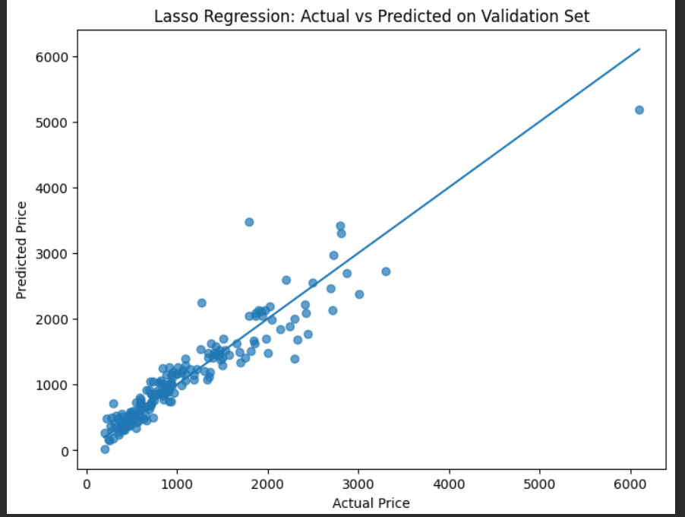

Decision Tree Regression
Decision Tree Regression was used as a non-linear model to predict laptop prices and to compare its performance with the linear models. Unlike Linear Regression, Ridge, and Lasso, a decision tree does not assume a linear relationship between the input features and the target. Instead, it learns a set of decision rules by splitting the data into smaller groups based on the values of the features. This makes it useful for capturing complex patterns and interactions in the laptop dataset that may not be handled well by linear models.
The same engineered dataset was used for the Decision Tree model. Features created from ScreenResolution, Memory, CPU_Type, Product, and GPU_Type were kept, since they added useful information about display quality, storage type and size, processor family, product line, and graphics category. For preprocessing, a separate pipeline was used for tree-based modeling. Numerical features were passed through without scaling because decision trees do not depend on feature magnitude, while categorical features were encoded using OneHotEncoder with handle_unknown="ignore". These steps were combined with the model inside a Pipeline so that preprocessing and training were handled consistently.
A baseline DecisionTreeRegressor was first trained using the default settings with a fixed random_state. The model was evaluated using 5-fold cross-validation on the training data and then tested on the validation set created from the 80/20 holdout split. The evaluation metrics used were R², RMSE, and MAE, which allowed direct comparison with the linear and regularized regression models. In addition, an Actual vs Predicted scatter plot was generated to visually examine the model’s predictions, and a learning curve based on mean squared error was plotted to study the training and validation behavior as the training size increased.
Because a baseline decision tree can easily overfit the training data, hyperparameter tuning was also performed to improve generalization. A RandomizedSearchCV procedure was used to search for better model settings. The tuned parameters included max_depth, min_samples_split, min_samples_leaf, and max_features. These parameters control the complexity of the tree, the minimum number of samples required to split a node, the minimum number of samples required in a leaf, and the number of features considered during splitting. By tuning these values, the goal was to reduce overfitting and produce a tree that performed better on unseen data.
After tuning, the best estimator from the randomized search was selected and evaluated again on the validation set. This tuned Decision Tree model achieved better generalization than the baseline version and provided a fair comparison with the linear models. The Decision Tree was especially useful in this project because laptop prices may depend on non-linear feature interactions, such as the combined effect of processor type, storage type, RAM, and display quality.
Overall, Decision Tree Regression added an important non-linear perspective to the project. It showed how a model based on recursive splitting can learn complex relationships without requiring feature scaling or explicit polynomial expansion. Even if the final best model was Ridge Regression, the Decision Tree helped demonstrate the effect of non-linear modeling and hyperparameter tuning on laptop price prediction, making it a valuable part of the overall analysis.
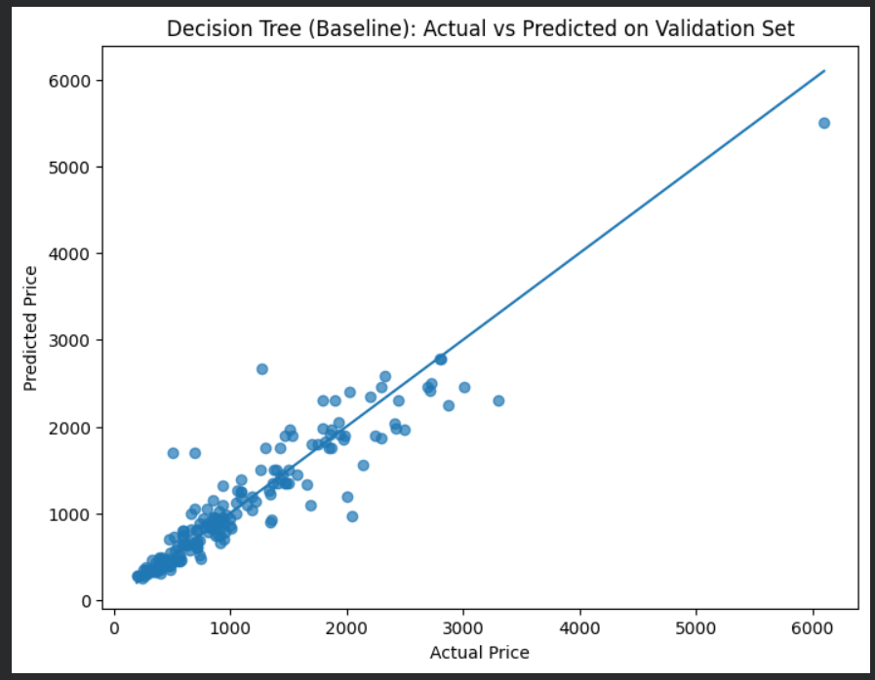

Polynomial Regression
Polynomial Regression was used to extend the basic Linear Regression model by allowing it to learn curved and interaction-based relationships between features and laptop price. While ordinary Linear Regression assumes that the relationship between each predictor and the target is strictly linear, Polynomial Regression creates additional features such as squared terms and interaction terms. This makes it possible to model more complex patterns in the data without switching to a completely different algorithm.
In this project, Polynomial Regression was not applied to all features, because the dataset contains many categorical variables and a large number of engineered attributes after one-hot encoding. Applying polynomial expansion to all features would greatly increase the number of variables and could lead to overfitting and very high computational cost. لذلك تم اختيار مجموعة محددة من أهم المتغيرات العددية فقط لاستخدامها في هذا model. The selected features were CPU_Frequency (GHz), RAM (GB), Weight (kg), ppi, and total_storage_gb. These variables were chosen because they are continuous numerical features and are strongly related to laptop price.
The model was built using a Pipeline consisting of three steps. First, StandardScaler was applied to normalize the selected numerical features so that they would be on a similar scale. This is important because polynomial expansion can make differences in magnitude larger. Second, PolynomialFeatures with degree=2 and include_bias=False was used to create squared terms and pairwise interaction terms from the selected inputs. Third, a standard LinearRegression model was fitted on these transformed features. In this way, the model remained linear in its coefficients, but it became capable of learning non-linear relationships in the original feature space.
The Polynomial Regression model was evaluated using the same 5-fold cross-validation strategy on the training data and then tested on the validation split. The same evaluation metrics were used as in the other models: R², RMSE, and MAE. After training, predictions on the validation set were compared with the actual prices using an Actual vs Predicted scatter plot. This helped show how closely the polynomial model captured the variation in laptop prices.
The main reason for including Polynomial Regression in the project was to test whether adding non-linear transformations to important numerical features would improve predictive performance compared with standard linear models. In laptop pricing, some relationships may not be perfectly linear. For example, the effect of RAM, storage, or pixel density on price may increase at different rates depending on the value range, and interactions between hardware features may also affect the final price. Polynomial Regression helps model such effects more clearly than ordinary Linear Regression.
Overall, Polynomial Regression provided a useful intermediate approach between simple linear models and more flexible non-linear models such as Decision Tree Regression. It allowed the project to examine whether controlled non-linearity could improve predictions while keeping the model relatively interpretable. Even if it was not ultimately selected as the final model, it was an important experiment because it showed how transforming a small group of key numerical features can help capture more complex pricing behavior in the laptop dataset.

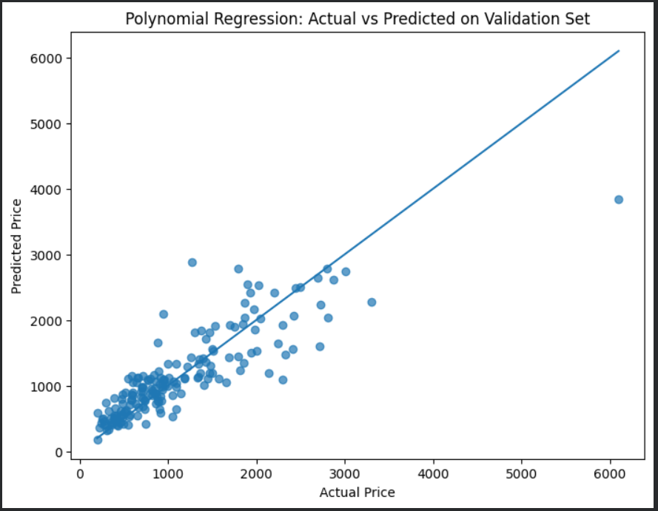

5.Prediction:
The best model we got is the ridge/ridge tuned by score 0.892

